**Modules in OOP**

* Module comprises of set of
  + Functions
  + Variables
  + Classes
  + Contracts
  + Templates
* To handle modules, we need a module system
  + Common JS
  + UMD [Universal Module Distribution]
  + AMD [Asynchronous Module Distribution]
* TypeScript uses “commonjs” module system.
* Modules are required to build library for application.
* Library comprises of functions, values, classes, contracts, template etc.
* You can export and import library into project.
* The TypeScript file scope is Module Scope.
* Every member in a module is private in access. It is not accessible outside the module.
* In order to access outside module, you have to mark it with “**export**”.

Syntax:  
export function ProductDetails()

{

}

* You can access and use the function in any application by importing the module.

Syntax:

import {CategoryDetails, ProductDetails} from '../Library/Modules/Product';

* A module can contain multiple functions marked as export.
* Any one function/member can be marked as **default export**.

Ex:

* Add following folders and files

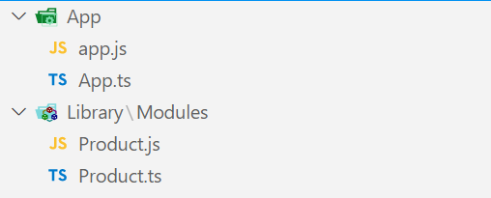

* Go to “Product.ts”

let productName:string = 'Samsung TV';

export default function ProductDetails(){

console.log(`Product Name : ${productName}`);

}

export function CategoryDetails(){

console.log(`Category : Electronics`);

}

* Go to “App.ts”

import ProductDetails, {CategoryDetails} from '../Library/Modules/Product';

CategoryDetails();

ProductDetails();

Ex:

* Category.ts

export function CategoryDetails(){

console.log(`Category : Electronics`);

}

* Product.ts

let productName:string = 'Samsung TV';

export default function ProductDetails(){

console.log(`Product Name : ${productName}`);

}

* App.ts

import {CategoryDetails} from "../Library/Modules/Category";

import ProductDetails from "../Library/Modules/Product";

CategoryDetails();

ProductDetails();

**Contracts in OOP**

* Contract defines rules for designing a component.
* In OOP contracts are designed by using “interface”.

Syntax:

export interface IName

{

// Rules

}

Ex:

* Add a new folder “Contracts”
* Add a new file “ProductContract.ts”

export interface ProductContract

{

Name:string;

Price:number;

Stock:boolean;

}

* Go to Modules
* Product.ts

import { ProductContract } from "../contracts/ProductContract";

let tv:ProductContract = {

Name: "Samsung TV",

Price: 45000.44,

Stock: true

}

export function ProductDetails(){

console.log(`

Name: ${tv.Name} \n

Price: ${tv.Price} \n

Stock: ${tv.Stock}

`)

}

* Go to “App.ts”

import { ProductDetails } from "../Library/Modules/Product";

ProductDetails();